**CLEANING AND SANITIZING**

Cleaning and sanitizing procedures must be part of the standard operating procedures that make up your food safety program. Improperly cleaned and sanitized surfaces allow harmful microorganisms to be transferred from one food to other foods.

**Cleaning** is the process of removing food and other types of soil from a surface, such as a dish, glass, or cutting board. Cleaning is done with a cleaning agent that removes food, soil, or other substances. The right cleaning agent must be selected because not all cleaning agents can be used on food-contact surfaces. (A food-contact surface is the surface of equipment or utensil that food normally comes into contact.) For example, glass cleaners, some metal cleaners, and most bathroom cleaners cannot be used because they might leave an unsafe residue on the food contact surface. The label should indicate if the product can be used on a food-contact surface. The right cleaning agent must also be selected to make cleaning easy. **Cleaning agents are divided into four categories:**

**1. Detergents** – Use detergents to routinely wash tableware, surfaces, and equipment. Detergents can penetrate soil quickly and soften it. Examples include dishwashing detergent and automatic dishwasher detergents.

**2. Solvent cleaners** – Use periodically on surfaces where grease has burned on. Solvent cleaners are often called degreasers.

**3. Acid cleaners** -- Use periodically on mineral deposits and other soils that detergents cannot remove. These cleaners are often used to remove scale in ware washing machines and steam tables.

**4. Abrasive cleaners** -- Use these cleaners to remove heavy accumulations of soil that are difficult to remove with detergents. Some abrasive cleaners also disinfect. Clean food-contact surfaces that are used to prepare potentially hazardous foods as needed throughout the day but no less than every four hours. If they are not properly cleaned, food that comes into contact with these surfaces could become contaminated.

**Sanitizing** is done using heat, radiation, or chemicals. Heat and chemicals are commonly used as a method for sanitizing in a restaurant; radiation rarely is. The item to be sanitized must first be washed properly before it can be properly sanitized. Some chemical sanitizers, such as chlorine and iodine, react with food and soil and so will be less effective on a surface that has not been properly cleaned.

**Sanitizing Methods**

1. **Heat.** There are three methods of using heat to sanitize surfaces – steam, hot water, and hot air. Hot water is the most common method used in restaurants. If hot water is used in the third compartment of a three-compartment sink, it must be at least 171oF (77oC). If a high-temperature ware washing machine is used to sanitize cleaned dishes, the final sanitizing rinse must be at least 180oF (82oC). For stationary rack, single temperature machines, it must be at least 165oF (74oC). Cleaned items must be exposed to these temperatures for at least 30 seconds.
2. **Chemicals**. Chemicals that are approved sanitizers are chlorine, iodine, and quaternary ammonium. Different factors influence the effectiveness of chemical sanitizers. The three factors that must be considered are:

* Concentration -- The presence of too little sanitizer will result in an inadequate reduction of harmful microorganisms. Too much can be toxic.
* Temperature -- Generally chemical sanitizers work best in water that is between 55oF(13oC) and 120oF (49oC).
* Contact time -- In order for the sanitizer to kill harmful microorganisms, the cleaned item must be in contact with the sanitizer (either heat or approved chemical) for the recommended length of time.

**Sanitizer Testing**

Every restaurant must have the appropriate testing kit to measure chemical sanitizer concentrations. To accurately test the strength of a sanitizing solution, one must first determine which chemical is being used -- chlorine, iodine, or quaternary ammonium. Test kits are not interchangeable so check with your chemical supplier to be certain that you are using the correct kit. The appropriate test kit must then be used throughout the day to measure chemical sanitizer concentrations.

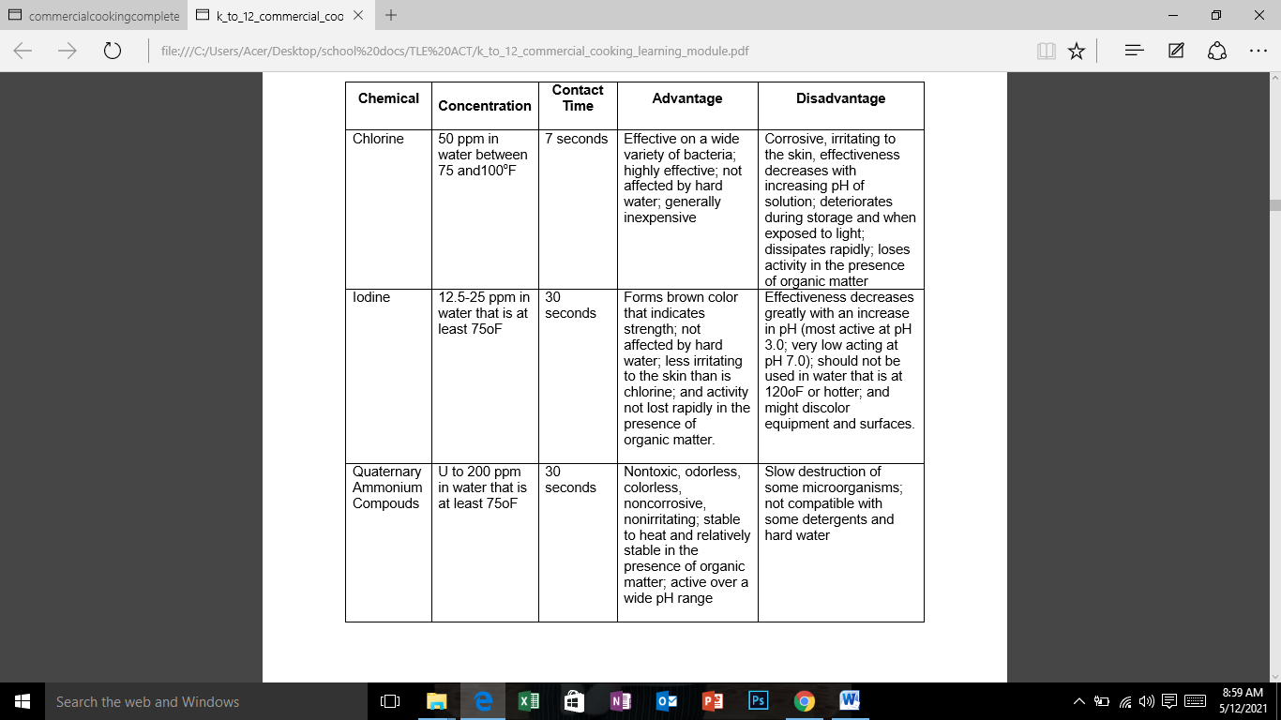**Advantages and Disadvantages of Different Chemical Sanitizers**

**How to Clean and Store Cooking Tools and Equipment**

1.) After measuring and mixing ingredients, soak all used mixing bowls, spatulas, measuring spoons and cups and mixer accessories in a tub of warm water.

2.) Use a damp washcloth to wipe off all cake mix splatter from the mixer. While your at it, wipe off any stray splatter from the countertops and nearby areas.

3.) Return electric mixers and other electronic equipment to their designated storage spaces.

4.) After cooking, soak used cake pans and muffin tins in warm water with dishwashing solution to soften the baked-on or burnt food.

5.) Wash all baking items and accessories by either hand washing or loading in a dishwasher (if dishwasher-safe).

6.) Dry all baking tools and equipment by air-drying on a drying rack or wiping with a dry dishcloth. Make sure all wooden spoons and accessories are dry before storing.

7.) Store all tools and equipment in their designated places. Put frequently used items in conveniently accessible locations. Gather and secure electrical cords to prevent entangled or snagging.

8.) Proper Storage and Handling. Proper Storage and Handling of cleaned and sanitized equipment and utensils is very important to prevent recontamination prior to use.

**Cleaned and Sanitized Equipment must be:**

* store on clean surfaces
* Handled to minimize contamination of food contact surface.

**Evaluation**

1. Complete the following table.

|  |  |  |
| --- | --- | --- |
| CHEMICAL | ADVANTAGES | DISADVANTAGES |
| 1.Chlorine | 1. | 1.  2. |
| 2.Iodine | 1.  2. | 1.  2. |
| 3.Quaternary Ammonium Compounds | 1.  2. | 1. |

II. Put a check (√) mark if the statement is correct and an (X) mark if incorrect.

1. Utensils need to be thoroughly washed in cold soapy water.

2. Follow the instructions on the sanitizer’s container carefully.

3. All utensils must then be thoroughly dried before they are re-used.

4. Cleaning will remove most of the dangerous bacteria present in the utensils.

5. Chemical sanitizer or very hot water were used in absence of dishwasher.

May 12,2021

Marssthie, Joanna, Criztel, Shanella

